**Day 48 and 49**

**What to do?**

You learned how to apply CNN on grey scale images. Now, try to do the same for RGB images, and also apply hyperparameter tuning and regularization.

**CIFAR-10:**

Network architecture:

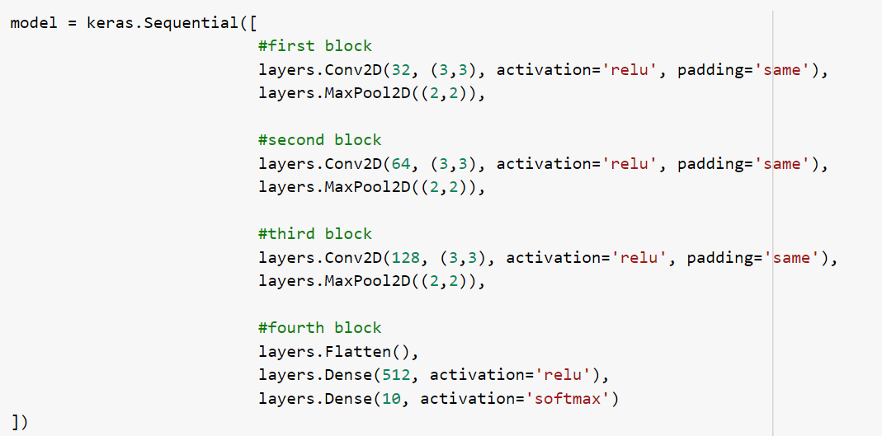

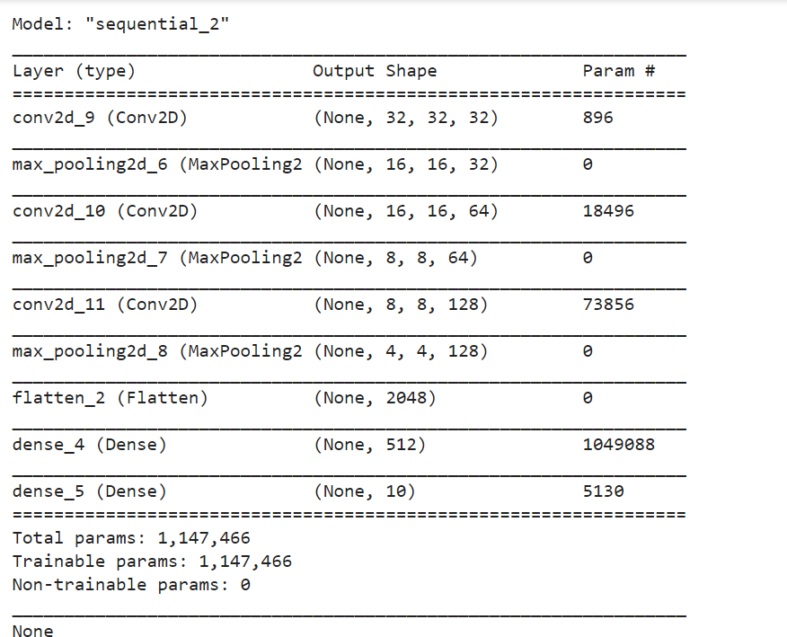

The model is then compiled with Adam optimizer with loss of sparse categorical cross entropy. The model is evaluated using accuracy. The model is run 22 epochs and 100 batch size, with early stopping.

Results:

* Training accuracy: 74.75%
* Testing accuracy: 63.56%

Results could be better, especially when data augmentation techniques are used. This was implemented just for the sake of the daily activity. When hyperparameter tuning was tried using keras tuner, it took long time to implement. Hence, taken a reference network was used to build the model.